(INSERT COMPANY LOGO) | 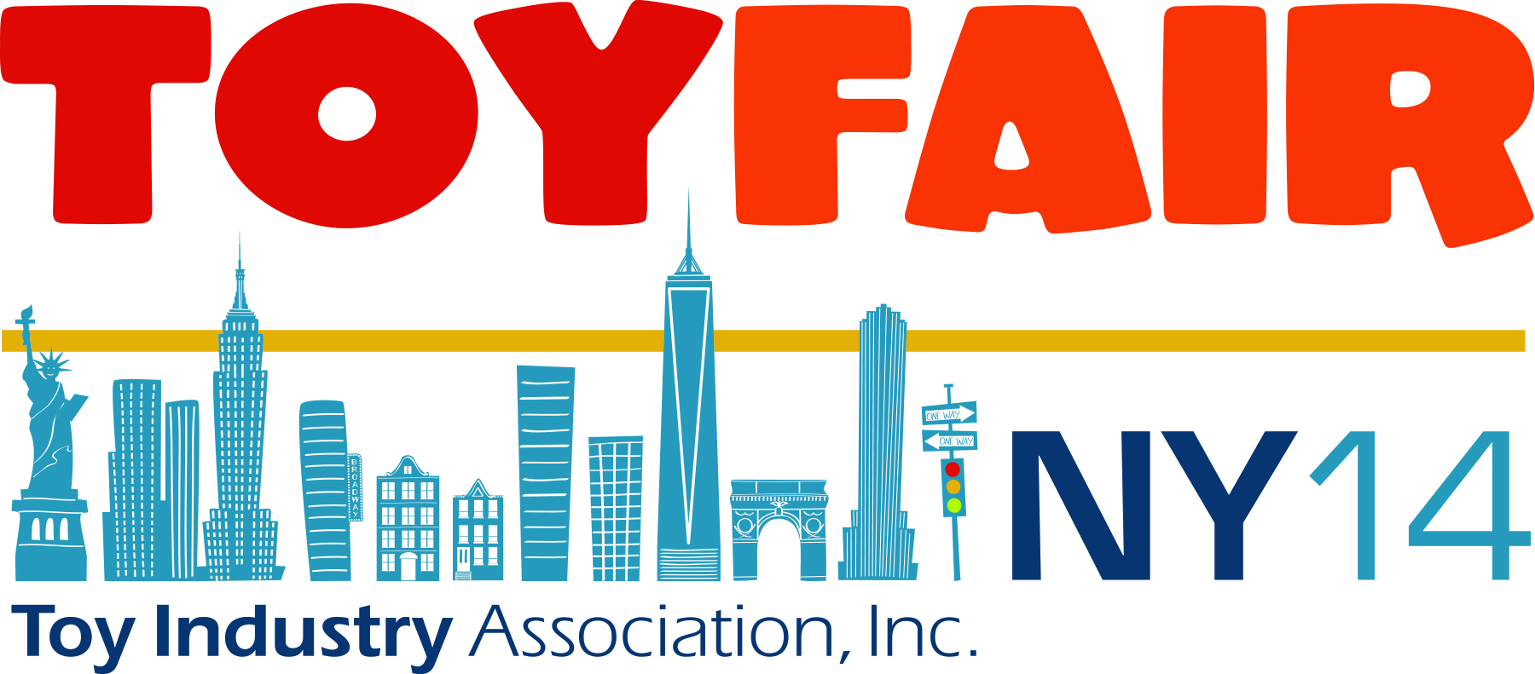

FOR IMMEDIATE RELEASE

Contact: Name
Phone Number
Email
Local (City) Company (Name of Company) Exhibiting at
American International Toy Fair in New York City
(OPTIONAL: INSERT PHOTO OF COMPANY REPS AT TOY FAIR. Include in photo caption the names of all shown.)

City, State | Date – Representatives of (name of company) traveled to New York City this week to exhibit at the 111th American International Toy Fair, the largest and most important toy and youth product trade show in the Western hemisphere. This is the (add number) year that (name of company) has debuted their latest toys (and/or games) to the thousands of buyers around the world who attend the show.

Toy Fair connects manufacturers, importers and distributors with 10,000+ forward-looking and fast-acting retailers from more than 100 countries … buyers who are on the lookout for everything from (add toy type your company sells) to (add toy type your company sells) that will attract the attention of kids and families.

“(Name of Company) is thrilled to be a part of the largest trade show in the Western Hemisphere,” said (Name, Title, Company). “Toy Fair enables us to connect with retailers from around the globe – which is very exciting and ultimately profitable.”
The show boasts over 1,100 exhibiting companies from around the world and more than 150,000 products showcased at Toy Fair every year.

The 111th American International Toy Fair (took place/is taking place) February 16-19, 2014 at the Jacob K. Javits Convention Center in New York City. For more information about the show visit ToyFairNY.com.

###

About (Name of company)
Add in a brief overview of your company.

About the American International Toy Fair
Toy Fair is a marketplace that is owned and operated by the Toy Industry Association (TIA), the not-for-profit trade association representing all businesses involved in creating and bringing toys and youth entertainment products to kids of all ages. For more information about the show, please visit www.ToyFairNY.com. To learn about the Toy Industry Association, visit www.ToyAssociation.org.

